Sample Run for the Client of Voice IRC

Cochran, Osecki, and Shaya (Group 14)

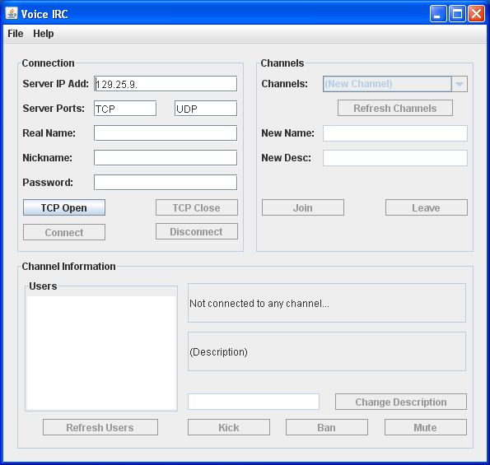

This is the view you are presented with upon opening the client.

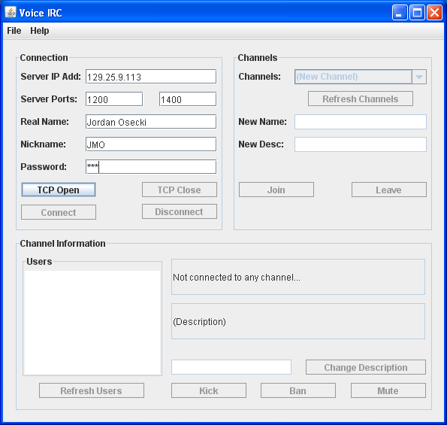

To begin connecting, fill in the information necessary

and click “TCP Open”, followed by “Connect”.

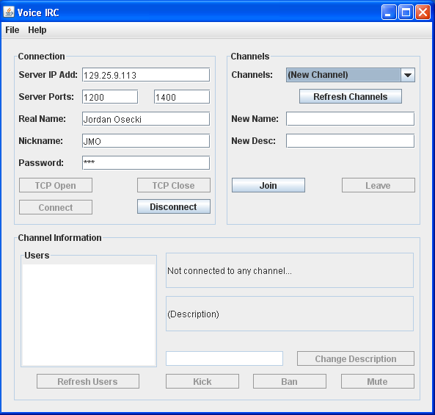

Once connected, the Channels panel will become enabled. Here you can either select a channel from the drop-down that already exists (using the Refresh Channels button to refresh the list at any time) or you can create a new one (and be the operator of this channel). Either select one or type in a new one and then click the join button.

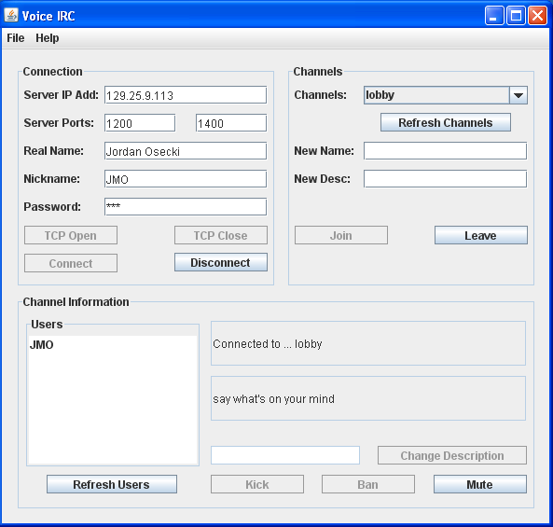

The channel “lobby” was selected from the dropdown list and joined. The Channel information panel has lit up in the bottom. Also, before you were hearing dial tone, but now you will begin to hear the voices for people in this channel. There is a list of users on the left which can be updated with the Refresh Users button. The two labels display the title and description of the channel you are currently connected to. You can also use the Mute button to locally mute any user by selecting their name on the list and then clicking “Mute”. To un-mute them, do the same thing. To Part, simply click “Leave”.

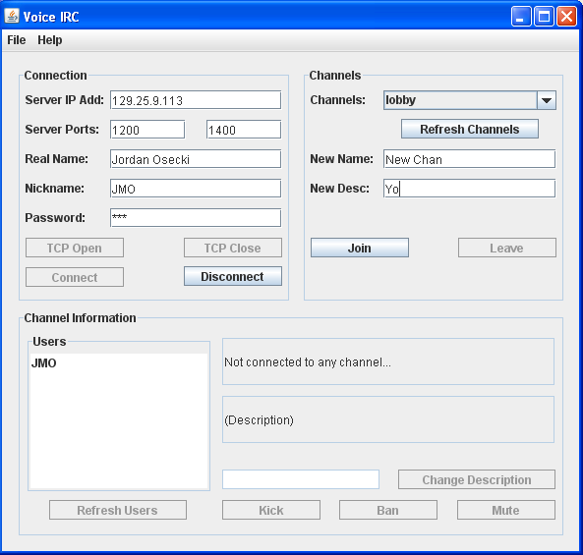

After leaving the channel, I can create one by defining a name and description and then clicking “Join”. In this channel I will be the operator.

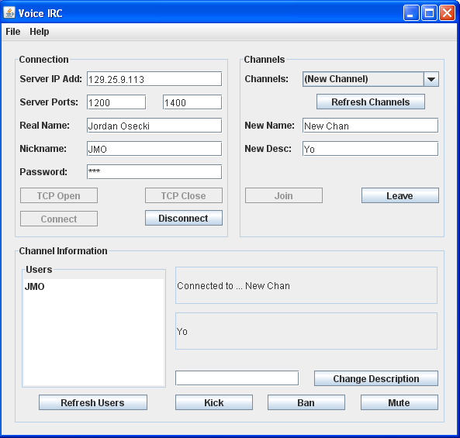

Now I am within a channel where I am the operator. As you can see, everything is the same but I can now select “Kick”, “Ban”, and “Change Description”. I can change the channel’s description or kick or ban different users by clicking a user name and then clicking their button. To disconnect from the server, simply click Disconnect and then TCP Close. The client will be back in the mode ready for TCP Open and then Connect.